Experiment No: 4
Aim: To study inheritance using typescript.

Theory:
Inheritance is an aspect of OOPs languages, which provides the ability of a program to create a new class from an existing class. It is a mechanism which acquires the properties and behaviors of a class from another class. The class whose members are inherited is called the base class, and the class that inherits those members is called the derived/child/subclass. In child class, we can override or modify the behaviors of its parent class.

TypeScript supports only single inheritance and multilevel inheritance. It doesn't support multiple and hybrid inheritance.

Syntax
We can declare a class inheritance as below.
class sub_class_name extends super_class_name {
// methods and fields
}
Single Inheritance Code:
class Parent{ protected a: string; constructor(a:string){ this.a = a;
}
}
class Child extends Parent{ protected b: string; constructor(a:string,b:string){ super(a);
this.b = b;
}
display():void{
console.log(`A: ${this.a}\nB: ${this.b}`);

}
}

const child = new Child("101","201"); child.display();
Output:

Multi-level Inheritance Code:
class Parent1{ protected a: string; constructor(a:string){ this.a = a;
}
}

class Child1 extends Parent1{ protected b: string; constructor(a:string,b:string){ super(a);
this.b = b;
}
}

class Child2 extends Child1{ protected c: string; constructor(a:string,b:string,c:string){ super(a,b);
this.c = c;
}
display():void{
console.log(`A: ${this.a}\nB: ${this.b}\nC: ${this.c}`); }
}

const newCHild = new Child2("Sarthak","Dikshant","Adarsh"); newCHild.display();

Output:
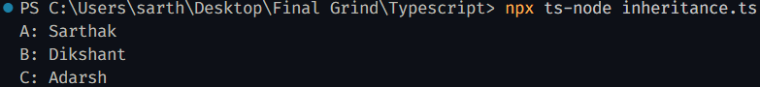

Conclusion:
Inheritance is a core principle of object-oriented programming (OOP) that helps in code reuse and modularity. TypeScript supports class-based inheritance, allowing developers to create structured and maintainable applications. By applying inheritance, developers can extend functionalities efficiently without redundant code.

